**ASSIGNMENT-19.4**

**TASK-1: Translate a Simple Program (Python →JavaScript)**

**Prompt:**

Write a python program to print natural numbers from 1 to 10 with loops.

**CODE WITH OUTPUT:**

**Python code converting in to Java script code:**

**Python program:**

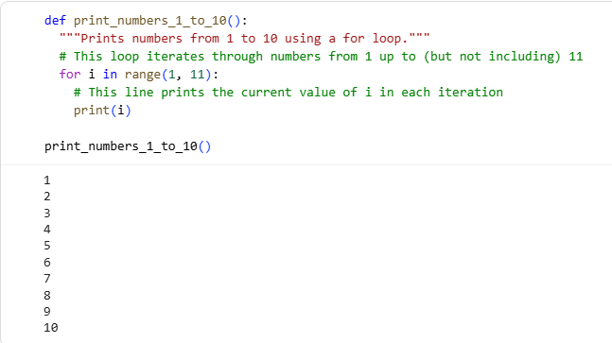

**Java script Program:**

Write a program in java script to print from 1 to 10 having class name main.

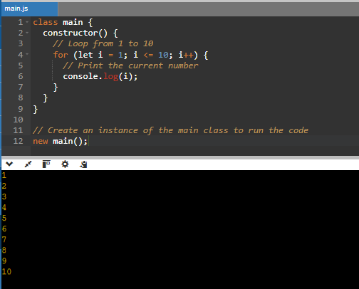

**TASK-2: Convert Conditional Statements (Java → Python)**

**Prompt:**

Write a java program with a function checknumber(int num) that prints positive, negative or zero demonstrate with examples.

**CODE WITH OUTPUT:**

**Java code converting in to Python code:**

**Java program:**

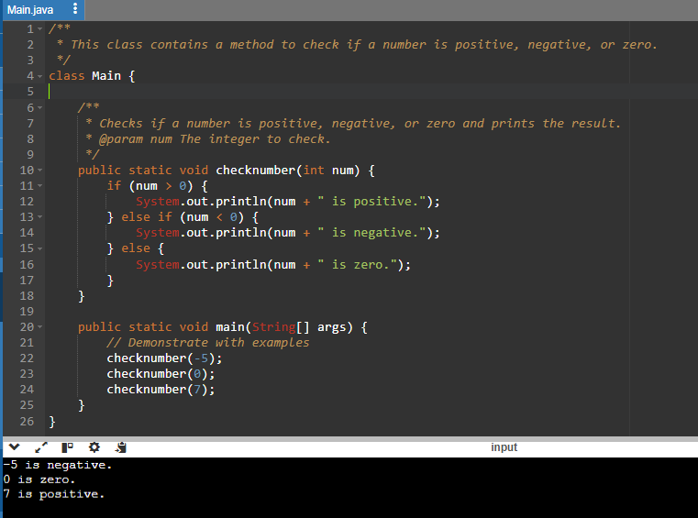

**Python Program:**

Write a java program with a function checknumber(int num) that prints positive, negative or zero demonstrate with examples.

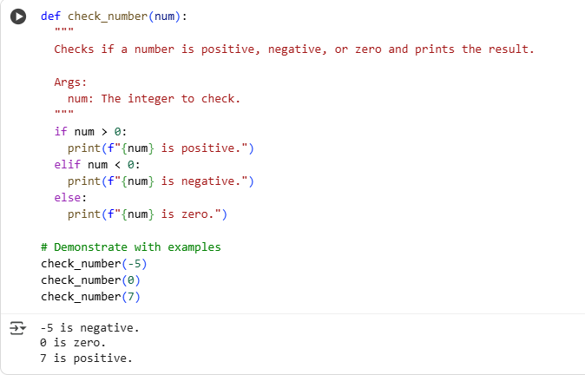

**TASK-3: Translate Recursive Function (Python → C++)**

**Prompt:**

Write a python function factorial (n) that calculates factorial of a number using recursion.

**CODE WITH OUTPUT:**

**Python code converting in to C++ code:**

**Python program:**

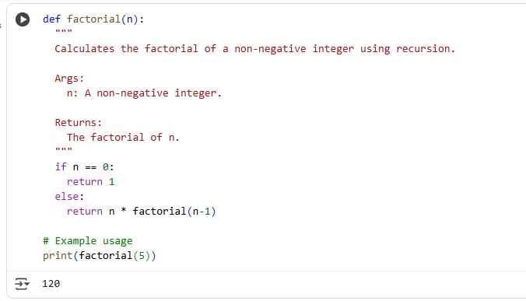

**C++ Program:**

Write a C++ function factorial (n) that calculates factorial of a number using recursion.

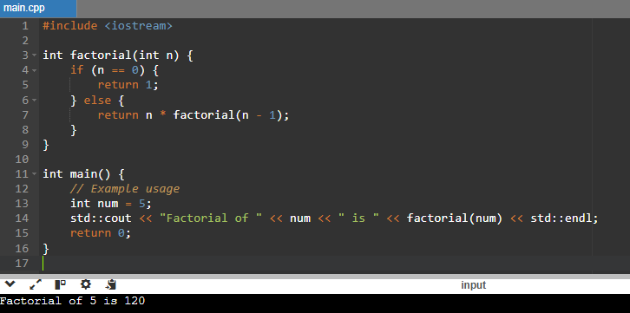

**TASK-4: Data Structures with Functions (JavaScript → Python).**

**Prompt:**

Write a JavaScript function print Students(students) that takes an array of student names and prints each name.

**CODE WITH OUTPUT:**

**Java script code converting in to Python code:**

**Java script program:**

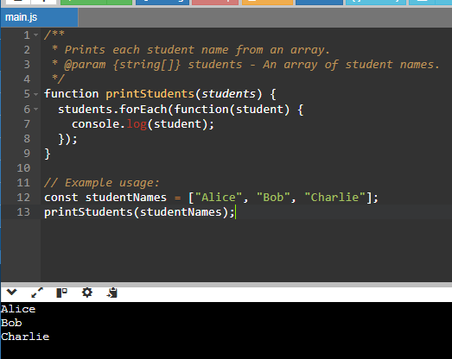

**Python program:**

Write a python function print Students(students) that takes an array of student names and prints each name using list.

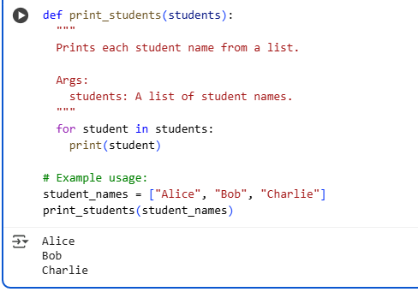

**TASK-5: Class & Object Translation (Python → Java)**

**Prompt:**

Write a Python program class Car with attributes like brand, model, year and add a method display_details() that prints car details.

**CODE WITH OUTPUT:**

**Python code converting into java code:**

**Python program:**

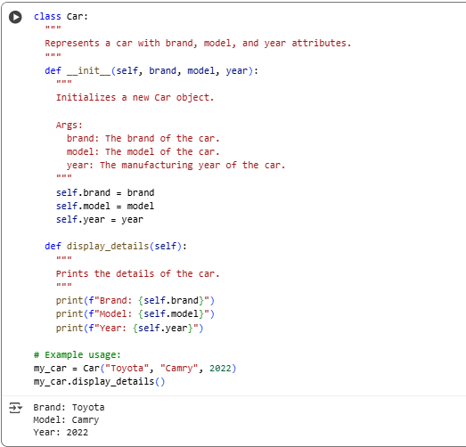

**Java program:**

Write a java program class Car with attributes like brand,model, year and add a method display_details() that prints car details.

